**Sample exam for Quiz 2**

Table VOTE in the following is for the next set of questions:

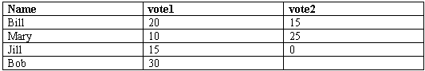

1. SELECT * FROM VOTE

WHERE Vote2 >=10

The execution of this query produces the following number of rows:

A) 1

B) 2

C) 3

D) 4

2. SELECT * FROM VOTE

WHERE Vote2 >=10

UNION

SELECT * FROM VOTE

WHERE Vote2 <10

The execution of this query produces the following number of rows:

A) 1

B) 2

C) 3

D) 4

3. SELECT COUNT(*) AS Nrows, COUNT(VOTE2) AS NVOTE2

FROM VOTE

The execution of this query produces the following result (Nrows shown before NVOTE2):

A) 4, 4

B) 3, 3

C) 4, 3

D) 4, null

4. SELECT SUM(VOTE1) AS S1, SUM(VOTE2) AS S2,

SUM(VOTE1) –SUM(VOTE2) AS S3, SUM(VOTE1-VOTE2) AS S4

FROM VOTE

The execution of this query produces the following result (shown in order of occurrence in the query):

A) 75 40 35 35

B) 75 40 75 35

C) 75 40 35 5

D) 75 40 40 40

The following data are in the tables Employee (primary key: Empno) and Department (primary key: Deptno). The questions refer to row numbers of this table. The first row of each table is row #1. Empdeptno in table Employee is a foreign key that refers to Deptno in the table Department. Deptmgr in the table Department is a foreign key that refers to Empno in the table Employee.

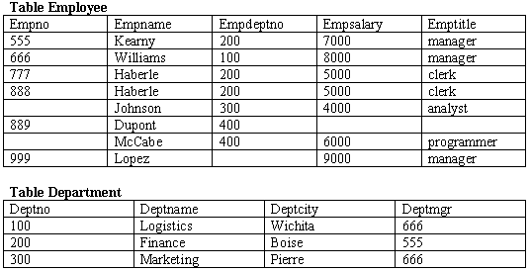

5. The relationship connecting Employee to Department and expressing that an employee belongs to a department (foreign key Empdeptno) is:

A) 1-M from Employee to Department

B) 1-M from Department to Employee

C) M-N

D) Self-referencing

6. The execution of this query

“select employee.empname, department.deptname, employee.salary

from Employee, department

where employee.Empdeptno = department.deptno”

produces the following number of rows:

A) 3

B) 4

C) 5

D) 6